**6. Write an algorithm and program to sort n numbers using Merge sort technique.**

**i) Using normal approach i.e. recursion illustrating Divide and Conquer**

**ii) Without using recursion**

**(i)Using Divide and Conquer**

#include<stdio.h>

main()

{

int n,i,a[100],lb,ub;

printf("\n enter the size=");

scanf("%d",&n);

for(i=0;i<n;i++)

{

scanf("%d",&a[i]);

}

lb=0;

ub=n-1;

mergesort(a,lb,ub);

for(i=0;i<n;i++)

{

printf("%d\t",a[i]);

}

getch();

}

void mergesort(int a[],int lb,int ub)

{

int mid;

if(lb<ub)

{

mid=(lb+ub)/2;

mergesort(a,lb,mid);

mergesort(a,mid+1,ub);

merge(a,lb,mid,ub);

}}

void merge(int a[],int lb,int mid,int ub)

{

int m,n,i,j,k;

m=mid-lb+1;

n=ub-mid;

int l1[10],l2[10];

for(i=0;i<m;i++)

{

l1[i]=a[lb+i];

}

for(j=0;j<n;j++)

{

l2[j]=a[mid+j+1];

}

i=0;

j=0;

k=lb;

while(i<m && j<n)

{

if(l1[i]<l2[j])

{

a[k]=l1[i];

k++;

i++;

}

else

{

a[k]=l2[j];

k++;

j++;

}}

while(i<m)

{

a[k]=l1[i];

k++;

i++;

}

while(j<n)

{

a[k]=l2[j];

k++;

j++;

}

}

**Output:-**

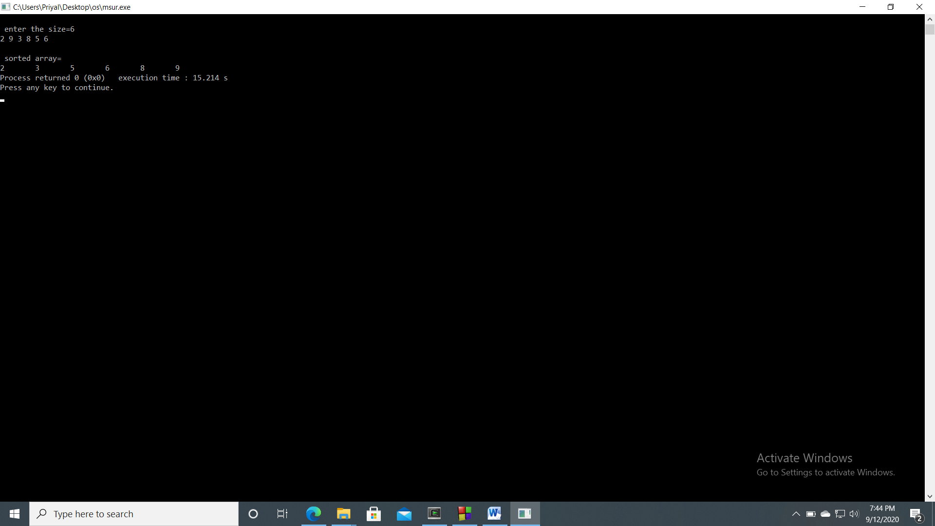

**(ii)Without recursion:-**

#include <stdio.h>

main()

{

int arr[20],temp[20],i,j,k,n,size,l1,h1,l2,h2;

printf("Enter the number of elements :\n ");

scanf("%d",&n);

printf("Enter element=");

for(i=0;i<n;i++)

{

scanf("%d",&arr[i]);

}

for(size=1; size < n; size=size*2 )

{

l1=0;

k=0;

while( l1+size < n)

{

h1=l1+size-1;

l2=h1+1;

h2=l2+size-1;

if( h2>=n )

h2=n-1;

i=l1;

j=l2;

while(i<=h1 && j<=h2 )

{

if( arr[i] <= arr[j] )

temp[k++]=arr[i++];

else

temp[k++]=arr[j++];

}

while(i<=h1)

temp[k++]=arr[i++];

while(j<=h2)

temp[k++]=arr[j++];

l1=h2+1;

}

for(i=l1; k<n; i++)

temp[k++]=arr[i];

for(i=0;i<n;i++)

arr[i]=temp[i];

}

printf("Sorted array :\n");

for( i = 0 ; i<n ; i++)

printf("%d ", arr[i]);

printf("\n");

}

**Output:-**

